

**BAHRIA UNIVERSITY (KARACHI CAMPUS**)

OPEN ENDED LAB II – **Fall22**

**(**System Programing (LAB) **CSC-454)**

Class: BSE [4]-5 (B) (Morning)

Course Instructor: **Engr Rizwan Fazal / Engr Rehan Baig**

Time Allowed: **1.5 Hour**

Student’s Name: **TAZAIM AMIR**

Max Marks: **6**

Reg. No: **71296**

# Instructions:

1. Submit your answers within file against each question with screenshot of both code and solution output.
2. File must be submitted in .pdf.

**[CLO#05, 6 marks]**

**SCENARIO:**

**You are working as a system engineer in a Microsoft vendor company that creates Apps for Microsoft store.**

**Your Project manager assigned you a task to design an application for code editor for Microsoft store. For that you need to analyze the basics of NotePad/WordPad applications that comes built-in with Microsoft windows. You need to create a process and analyze the following for notepad and WordPad.**

**Q1:** Run a loop or Use Recursion which enable program to print 5 times following for both Notepad and WordPad **(versionId, ThreadId, processId)**, meanwhile use exit thread function that-should be interrupt when counter reaches on 4rth iteration. (**4 Marks**)

**FOR NOTEPAD CODE:**

#include<iostream> #include<Windows.h> using namespace std; int main() {

HANDLE hprocess = NULL; HANDLE hthread = NULL; STARTUPINFOW si; PROCESS_INFORMATION pi;

DWORD dwProcessId = 0; DWORD dwthreadId = 0;

ZeroMemory(&si, sizeof(si));

ZeroMemory(&pi, sizeof(pi));

DWORD Ret = 0, dwPID = 0, dwTID = 0, dwPver = 0;

dwPID = GetCurrentProcessId();

cout << "GetCurrentProcessId: " << dwPID << endl;

dwTID = GetCurrentThreadId();

cout << "GetCurrentThreadID: " << dwTID << endl;

cout << "Command Line:%s\n" << GetCommandLine() << endl; dwPver = GetProcessVersion(dwPID);

cout << "Get Process Version: " << dwPver << endl;

cout << "Starting another process i.e. child process\n" << endl;

BOOL bCreateProcess = CreateProcessW(L"C:\\Windows\\System32\\notepad.exe", NULL, NULL, NULL, FALSE, 0, NULL, NULL, &si, &pi);

if (bCreateProcess == false) { cout << "Failed" << endl;

}

cout << "Create process successfully" << endl; cout << "ProcessId" << pi.dwProcessId << endl; cout << "ThreadId" << pi.dwThreadId << endl;

return 0;

}

**OUTPUT:**

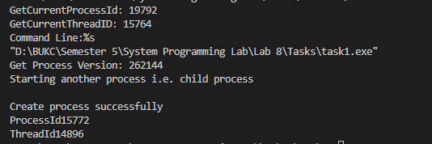



**FOR MSWORD CODE:**

#include<iostream> #include<Windows.h> using namespace std; int main() {

HANDLE hprocess = NULL; HANDLE hthread = NULL; STARTUPINFOW si; PROCESS_INFORMATION pi;

DWORD dwProcessId = 0; DWORD dwthreadId = 0; ZeroMemory(&si, sizeof(si)); ZeroMemory(&pi, sizeof(pi));

DWORD Ret = 0, dwPID = 0, dwTID = 0, dwPver = 0;

dwPID = GetCurrentProcessId();

cout << "GetCurrentProcessId: " << dwPID << endl;

dwTID = GetCurrentThreadId();

cout << "GetCurrentThreadID: " << dwTID << endl;

cout << "Command Line:%s\n" << GetCommandLine() << endl; dwPver = GetProcessVersion(dwPID);

cout << "Get Process Version: " << dwPver << endl;

cout << "Starting another process i.e. child process\n" << endl;

BOOL bCreateProcess = CreateProcessW(L"C:\\Program Files\\Microsoft Office\\Office16\\WINWORD.exe", NULL, NULL, NULL, FALSE, 0, NULL, NULL, &si, &pi);

if (bCreateProcess == false) { cout << "Failed" << endl;

}

cout << "Create process successfully" << endl; cout << "ProcessId" << pi.dwProcessId << endl; cout << "ThreadId" << pi.dwThreadId << endl;

return 0;

}

**OUTPUT:**

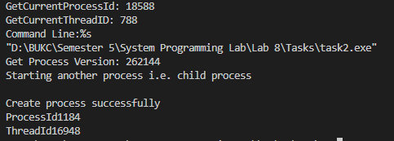

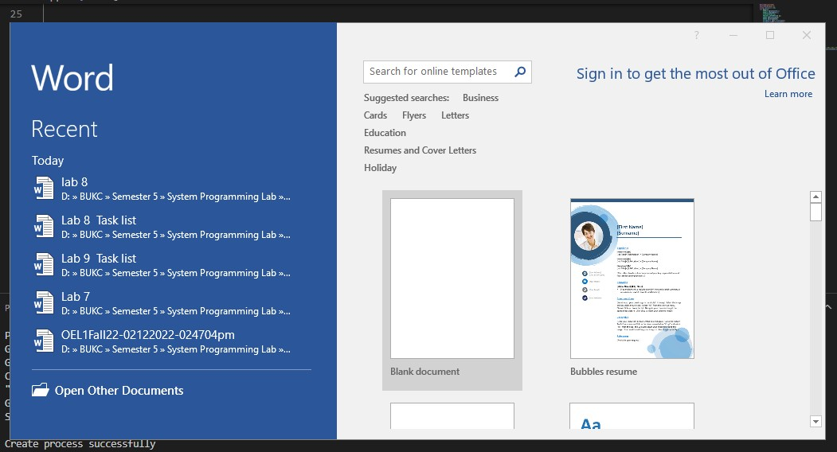

**Q2:** Write a code for any two synchronization objects from following. (**2 Marks**)

1. Events

**CODE:**

#include <windows.h> #include <stdio.h>

#define THREADCOUNT 4 HANDLE ghWriteEvent;

HANDLE ghThreads[THREADCOUNT];

DWORD WINAPI ThreadProc(LPVOID);

void CreateEventsAndThreads(void)

{

int i;

DWORD dwThreadID;

ghWriteEvent = CreateEvent( NULL,

TRUE, FALSE,

TEXT("Write an Event")

);

if (ghWriteEvent == NULL)

{

printf("Creation of an Event failed (%d)\n", GetLastError()); return;

}

for (i = 0; i < THREADCOUNT; i++)

{

ghThreads[i] = CreateThread( NULL,

0,

ThreadProc, NULL,

0,

&dwThreadID);

if (ghThreads[i] == NULL)

{

printf("CreateThread failed (%d)\n", GetLastError()); return;

}

}

}

void WriteToBuffer(VOID)

{

printf("Main thread writing to the shared buffer...\n");

if (!SetEvent(ghWriteEvent))

{

printf("SetEvent failed (%d)\n", GetLastError()); return;

}

}

void CloseEvents()

{

CloseHandle(ghWriteEvent);

}

int main(void)

{

DWORD dwWaitResult;

CreateEventsAndThreads();

WriteToBuffer();

printf("Main thread waiting for threads to exit...\n");

dwWaitResult = WaitForMultipleObjects( THREADCOUNT,

ghThreads, TRUE, INFINITE);

switch (dwWaitResult)

{

case WAIT_OBJECT_0:

printf("All threads ended, cleaning up for application exit...\n"); break;

default:

printf("WaitForMultipleObjects failed (%d)\n", GetLastError()); return 1;

}

CloseEvents();

return 0;

}

DWORD WINAPI ThreadProc(LPVOID lpParam)

{

UNREFERENCED_PARAMETER(lpParam);

DWORD dwWaitResult;

printf("Thread %d waiting for write event...\n", GetCurrentThreadId()); dwWaitResult = WaitForSingleObject(

ghWriteEvent, INFINITE);

switch (dwWaitResult)

{

case WAIT_OBJECT_0:

printf("Thread %d reading from buffer\n", GetCurrentThreadId());

break;

default:

printf("Wait error (%d)\n", GetLastError()); return 0;

}

printf("Thread %d exiting\n", GetCurrentThreadId()); return 1;

}

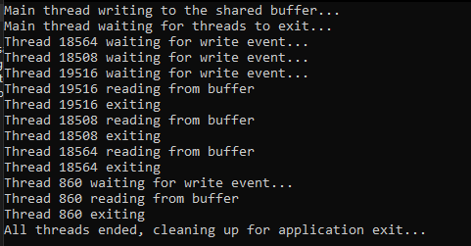**OUTPUT:**

1. Semaphores

**CODE:**

#include <windows.h> #include <stdio.h>

#define MAX_SEM_COUNT 10

#define THREADCOUNT 12 HANDLE ghSemaphore;

DWORD WINAPI ThreadProc(LPVOID);

int main(void)

{

HANDLE aThread[THREADCOUNT];

DWORD ThreadID; int i;

ghSemaphore = CreateSemaphore( NULL,

MAX_SEM_COUNT, MAX_SEM_COUNT, NULL);

if (ghSemaphore == NULL)

{

printf("CreateSemaphore error: %d\n", GetLastError()); return 1;

}

// Create worker threads

for (i = 0; i < THREADCOUNT; i++)

{

aThread[i] = CreateThread( NULL,

0, (LPTHREAD_START_ROUTINE)ThreadProc, NULL,

0,

&ThreadID);

if (aThread[i] == NULL)

{

printf("CreateThread error: %d\n", GetLastError()); return 1;

}

}

WaitForMultipleObjects(THREADCOUNT, aThread, TRUE, INFINITE);

for (i = 0; i < THREADCOUNT; i++)

CloseHandle(aThread[i]); CloseHandle(ghSemaphore);

return 0;

}

DWORD WINAPI ThreadProc(LPVOID lpParam)

{

UNREFERENCED_PARAMETER(lpParam);

DWORD dwWaitResult;

BOOL bContinue = TRUE;

while (bContinue)

{

dwWaitResult = WaitForSingleObject(

ghSemaphore, 0L);

switch (dwWaitResult)

{

case WAIT_OBJECT_0:

printf("Thread %d: wait succeeded\n", GetCurrentThreadId()); bContinue = FALSE;

Sleep(5);

if (!ReleaseSemaphore( ghSemaphore,

1, NULL))

{

printf("ReleaseSemaphore error: %d\n", GetLastError());

}

break;

case WAIT_TIMEOUT:

printf("Thread %d: wait timed out\n", GetCurrentThreadId()); break;

}

}

return TRUE;

}

**OUTPUT:**

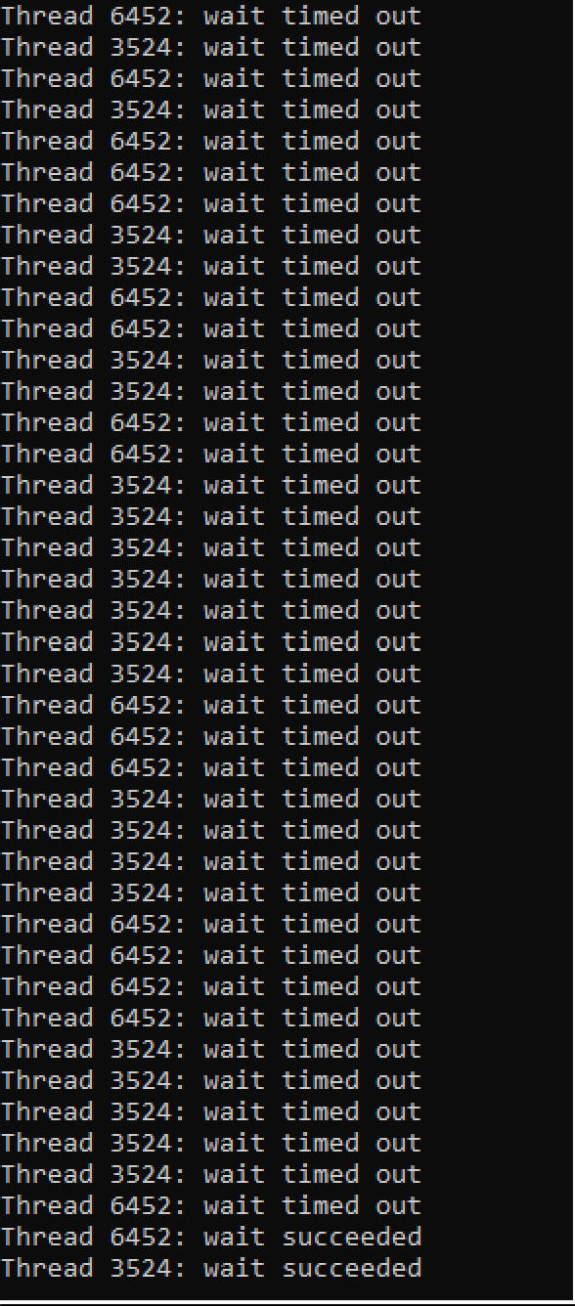

1. Mutexes

# CODE:

#include <windows.h> #include <stdio.h>

#define THREADCOUNT 2 HANDLE ghMutex;

DWORD WINAPI WriteToDatabase(LPVOID);

int main(void)

{

HANDLE aThread[THREADCOUNT];

DWORD ThreadID; int i;

ghMutex = CreateMutex( NULL,

FALSE, NULL);

if (ghMutex == NULL)

{

printf("Creation of Mutex error: %d\n", GetLastError()); return 1;

}

for (i = 0; i < THREADCOUNT; i++)

{

aThread[i] = CreateThread( NULL,

0,

(LPTHREAD_START_ROUTINE)WriteToDatabase, NULL,

0,

&ThreadID);

if (aThread[i] == NULL)

{

printf("Creation of Thread error: %d\n", GetLastError()); return 1;

}

}

WaitForMultipleObjects(THREADCOUNT, aThread, TRUE, INFINITE);

for (i = 0; i < THREADCOUNT; i++)

CloseHandle(aThread[i]); CloseHandle(ghMutex);

return 0;

}

DWORD WINAPI WriteToDatabase(LPVOID lpParam)

{

UNREFERENCED_PARAMETER(lpParam);

DWORD dwCount = 0, dwWaitResult; while (dwCount < 20)

{

dwWaitResult = WaitForSingleObject( ghMutex,

INFINITE);

switch (dwWaitResult)

{

case WAIT_OBJECT_0: try {

printf("Thread %d writing to database...\n", GetCurrentThreadId());

dwCount++;

}

finally {

if (!ReleaseMutex(ghMutex))

{

}

}

break;

case WAIT_ABANDONED:

return FALSE;

}

}

return TRUE;

}

**OUTPUT:**

